朝陽科技大學入學申請表
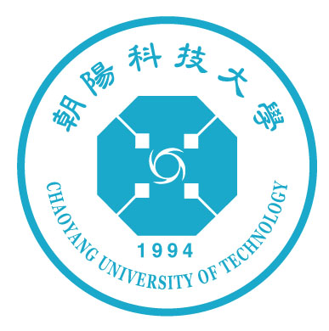
請貼相片

Attach recent bust
photograph here

APPLICATION FOR ADMISSION
Chaoyang University of Technology
填寫前請先閱讀申請人注意事項/Please read INSTRUCTIONS first.

1.申請人資料/Personal information
名/Given name: 姓/Family name:
中文姓名/Chinese name: 國籍/Nationality: 性別/Sex:□男/M □女/F
出生日期/Date of birth: 年/Year 月/Month 日/Day
護照號碼/Passport NO.: 學生證號/Student ID.:
通訊處/Mailing address:
E-mail: 傳真/FAX: 電話/TEL:
2.學歷/Educational background
學 校 修業起迄年月 主 修 文憑
Educational Institute Duration (from/to) Field of Study Diploma

3.語言能力/Language proficiency
讀/Reading 寫/Writing 聽/Listening 說/Speaking
中文/Chinese:
英文/English:
(請用優,良,可,差/Please use one of these words : Excellent, Good, Fair, Poor)

4.讀書計畫/Plan of study
修讀學位/Degree program: □碩士/Master □學士(四年制)/Bachelor of four year program
□學士(二年制)/Bachelor of two year program □選讀學分/Part-time program
申請系所別或選讀科目/Department to enroll at or courses to take:

留學動機與計畫(可另附紙張)/Objective and detailed plan of study(please attach additional paper if necessary):

5.在華研習期間費用來源/Means of financial support:

6.健康情形/Health condition:

申請人簽名/Signature of applicant: 日期/Date:
朝陽科技大學
Chaoyang University of Technology
申請人注意事項 Instructions

1.本校大學部教學以中文為主，申請修讀大學部課程者最好具備中文聽講能力。
Instruction in this university is mainly given in Mandarin Chinese; applicants for undergraduate programs had better be proficient in the Chinese language, particularly in speaking and listening.
2.申請時請檢附下列表件提出申請:
(1)入學申請表(含中文或英文留學計畫書)。
(2)畢業證書影印本與公證之中文或英文翻譯本各一份，應屆畢業生得以證明即將畢業之函件代替。
(3)成績單英文譯本(請由原校加蓋封章後直接寄交本校註冊組)。
(4)密封之推薦書兩份。申請修讀大學部課程者須包含一份中國語文教師推薦書，內容包含對申請人中國語文能力(讀、寫、聽、說)之說明。
(5)健康證明(包含AIDS病毒有關檢查)。
(6)就學財力證明書。
(7)護照或其他國籍證明文件影印本。
※ 各系所若有特別要求資料，將另行通知補繳。
Application for admission must include the following materials:
(1)Application for admission (including a statement of study plan written in Chinese or English).
(2)A photocopy of an appropriate diploma with a notarized Chinese or English translation. (Those who will graduate later in the same academic year may submit a document attesting to their forthcoming graduation instead).
(3)A transcript in English with imprinted seal and signature of the registrar which must be sent directly by the applicant’s school to the registrar of this university.
(4)Two letters of recommendation in sealed envelopes.(For applicants for undergraduate programs, one of the letter should be prepared by an instructor of Chinese language which state the Chinese proficiency including reading, writing, listening, and speaking.)
(5)A statement of health condition, including a report of AIDS tests, issued by a practicing physician.
(6)A statement of financial support for study.
(7)A photocopy of passport or other equivalent supporting documents.
※ Other documents may be required by certain departments or graduate schools; in this case, the applicant will be informed.
3.申請件請郵寄至: For application please write to:
中華民國‧台灣 41349 Division of Academic Exchange and Cooperation
台中縣霧峰鄉吉峰東路168號 Chaoyang University of Technology
朝陽科技大學 學術交流組 收 168 Gifeng E. Rd., Wufeng Taichung County, Taiwan,R.O.C.
WWW: http://www.cyut.edu.tw
E-Mail: ias@cyut.edu.tw FAX: 886-4-23742317 TEL: 886-4-23323000

